**Investigating the Impact of the COVID-19 Pandemic on the Economy**

Nora Aydinyan, Umayeer Milky, Severin Santana, David Wanjala

Data Analysis with R

Dr. Thor Veen

8th December 2021

The 2020 outbreak of the novel coronavirus is considered the most significant public health threat caused by a respiratory virus since 1918 [(Sen-Crowe et al., 2020)](https://www.zotero.org/google-docs/?hnkBS2). Consequently, there have been tremendous global efforts undertaken by public health professionals and government offices alike to help thwart its transmission. Among such efforts, lockdowns, restricting social gatherings and imposing strict social distancing policies have proven most effective [(Rubin et al., 2020)](https://www.zotero.org/google-docs/?NqriCQ). These measures however often result in the closure of entire industries within a country, impacting people's ability to either create or find work and earn a living. Therefore, their spending power within an economy reduces. Because of this, we would expect the COVID-19 pandemic to affect a country's economy. In this analysis, we examine how a surge in the number of COVID-19 cases impacts the economic activity of three different countries- the United States, Canada, and Germany. We use stock indices prices (Table 1) as a proxy for assessing these countries' economic activity. We then perform statistical analyses to determine the correlation between these countries’ economic activity, first measured as percentage difference and then as percentage change in daily stock index prices and the reported COVID-19 cases in the respective countries. Our null hypothesis is that there is no correlation between daily reported COVID-19 cases and market activity. Alternatively, we expect to see a weak to strong correlation between daily reported COVID-19 cases and market activity.

**Table 1. Stock Market Indices for Different Countries**

|  |  |
| --- | --- |
| **Countries** | **Stock Market Indices** |
| United States of America | DJI, NASDAQ, SP500 |
| Canada | TSX |
| Germany | DEX |

**Methods of analysis and Workflow outline**

We began by accessing and downloading stock indices price data and COVID-19 data from different sources (see **Appendix 1** for our data sources). This data, which can be found in a.data.raw project folder, was downloaded manually through the browser. This step was then followed by cleaning and tidying the data to ensure, for example, the correct structure and formatting for variable types. Procedures for cleaning and tidying data are in the 2. Data.Management.R script. The resulting cleaned data sets can be accessed from the b.data.clean project folder. We then carried out an exploratory data analysis to determine the most appropriate correlational statistical test to run on the available data sets. The codes for these are located in the 3. Data.analysis.R script. Once we had deduced the appropriate test, we performed this on the data and stored the results in the output folder. Finally, we visualized these results and provided the figures in the figures project folder.

Our analysis of the cleaned data involved determining the correlation between stock market activity and the number of COVID-19 cases. We first used the daily highest and lowest prices of each stock index to determine a value for the activity of the stock markets (expressed as percentage difference). The greater this value, the higher the activity of the stock market on any given day. Furthermore, the daily opening and closing prices of each stock index were used to determine the percentage change between them across a given day. The percentage difference gives us a measure of the absolute difference in the day whereas percentage change is directional, indicating when we have a negative or positive difference in stock market prices for that day. We then used the cor() function in R to calculate the correlation coefficients for the daily number of COVID-19 cases in each country and the activity of their respective stock markets. We also calculated the correlation coefficients between the number of daily COVID-19 cases in a given country and the percentage difference in stock market prices of that country. To determine the statistical significance of these correlations, we performed Pearson’s correlation test.

**Results**

*Correlation between COVID-19 cases and stock market activity*

The number of daily COVID-19 cases and stock market activity, measured as percentage difference, had a negative correlation for all three countries (*Figure 1*). This shows that with an increase in the number of COVID-19 cases, the activity of the stock market decreased over time in our countries of interest. All three stock market indices we used for the United States showed the same trend (*Figure 2*). The Pearson correlation test results showed these correlations were statistically significant (P-Value < 0.05) (Table 2).

**Table 2. Pearson Correlation Test P-Values for Stock Market Activity**

|  |  |
| --- | --- |
| **Correlation Variables (x, y)** | **P-Value** |
| Number of Daily COVID-19 cases in USA, SP500 activity | 4.942e-10 |
| Number of Daily COVID-19 cases in USA, NASDAQ activity | 1.625e-10 |
| Number of Daily COVID-19 cases in USA, DJI activity | 1.643e-11 |
| Number of Daily COVID-19 cases in Canada, TSX activity | 5.133e-09 |
| Number of Daily COVID-19 cases in Germany, DAX activity | 9.227e-07 |

*Correlation between COVID-19 cases and the percentage difference*

For all three countries, there was little to no correlation between the daily number of COVID-19 cases and the respective percentage change between the opening and closing stock market prices (*Figure 3*). This implies that the number of COVID-19 cases did not strongly influence the opening or closing prices of a stock market on a given day in these countries. The different stock market indices used for the US also show the same trend (*Figure 4*). The Pearson correlation test results showed these correlations were statistically insignificant (P-Value > 0.05) (Table 3).

**Table 3. Pearson Correlation Test P-Values for Percentage Difference**

|  |  |
| --- | --- |
| **Correlation Variables (x, y)** | **P-Value** |
| Number of Daily COVID-19 cases in USA, SP500 Percentage Difference | 0.5174 |
| Number of Daily COVID-19 cases in USA, NASDAQ Percentage Difference | 0.8718 |
| Number of Daily COVID-19 cases in USA, DJI Percentage Difference | 0.6384 |
| Number of Daily COVID-19 cases in Canada, TSX Percentage Difference | 0.2073 |
| Number of Daily COVID-19 cases in Germany, DAX Percentage Difference | 0.6544 |

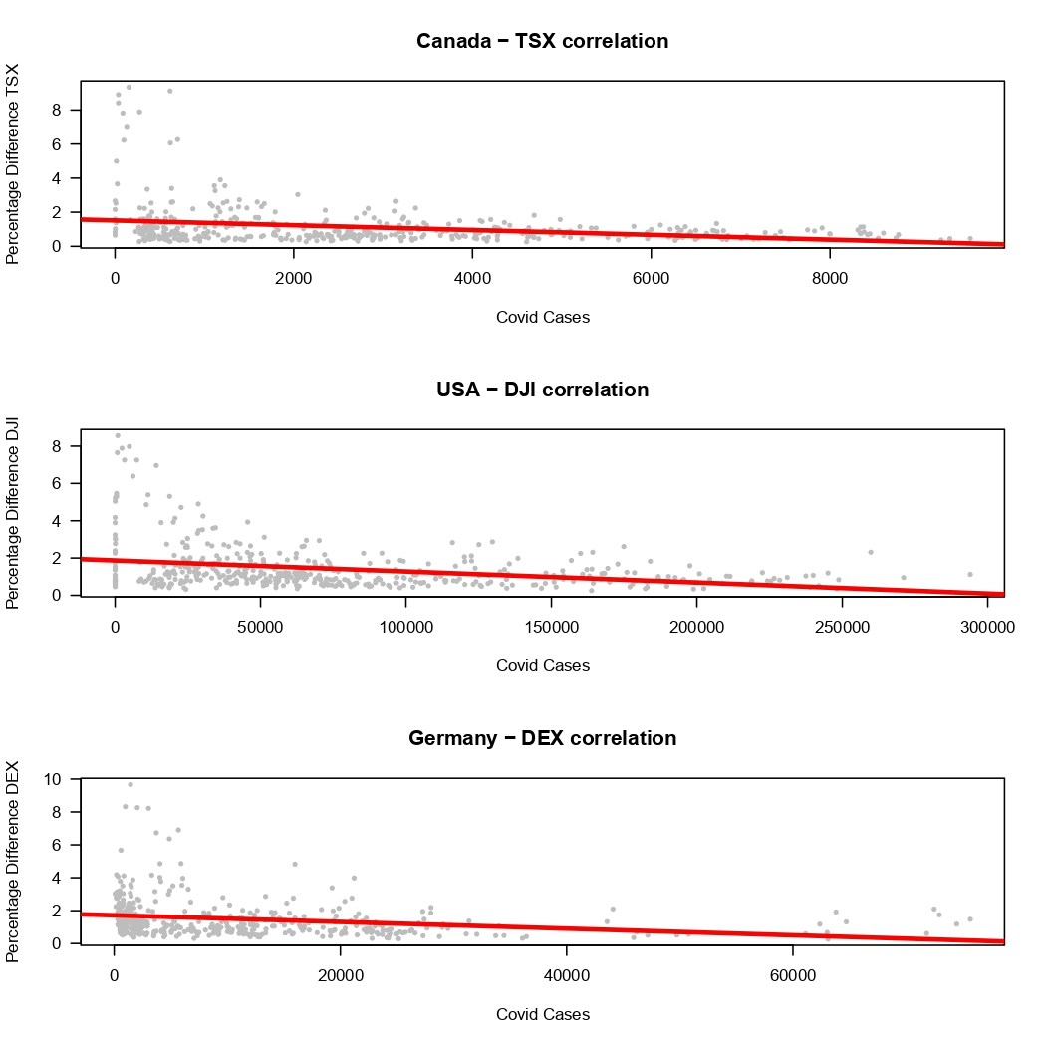

*Figure 1. Correlation between daily COVID-19 cases and stock market activity for different countries*.  
(from top to bottom) Correlation Coefficients: -0.272, -0.303, and -0.229.

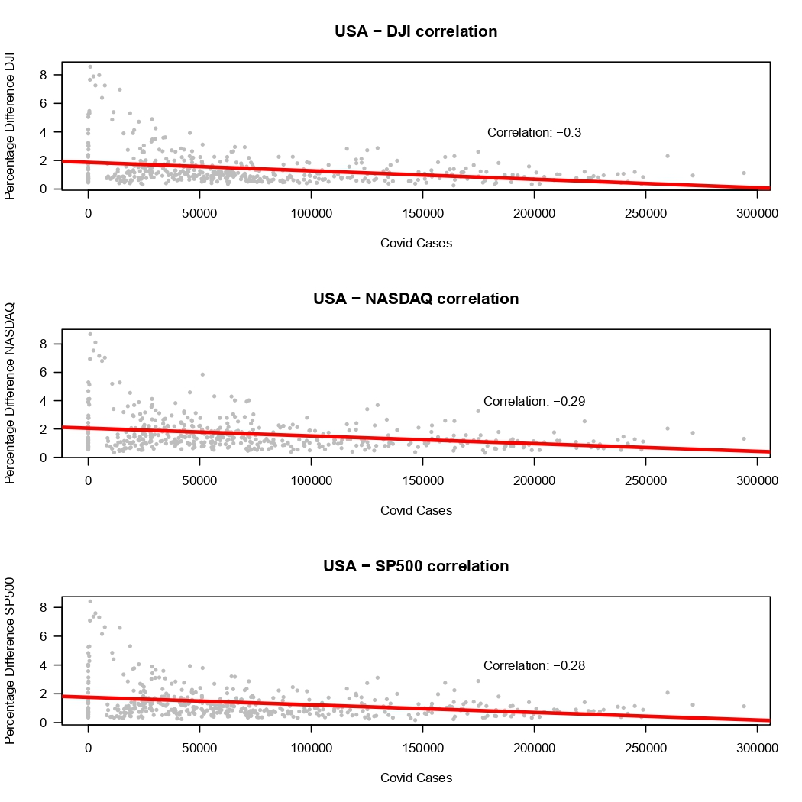

*Figure 2. Correlation between daily COVID-19 cases and stock market activity for the USA*.   
Correlation coefficients do not greatly vary. All three stock market indices show the same trend.

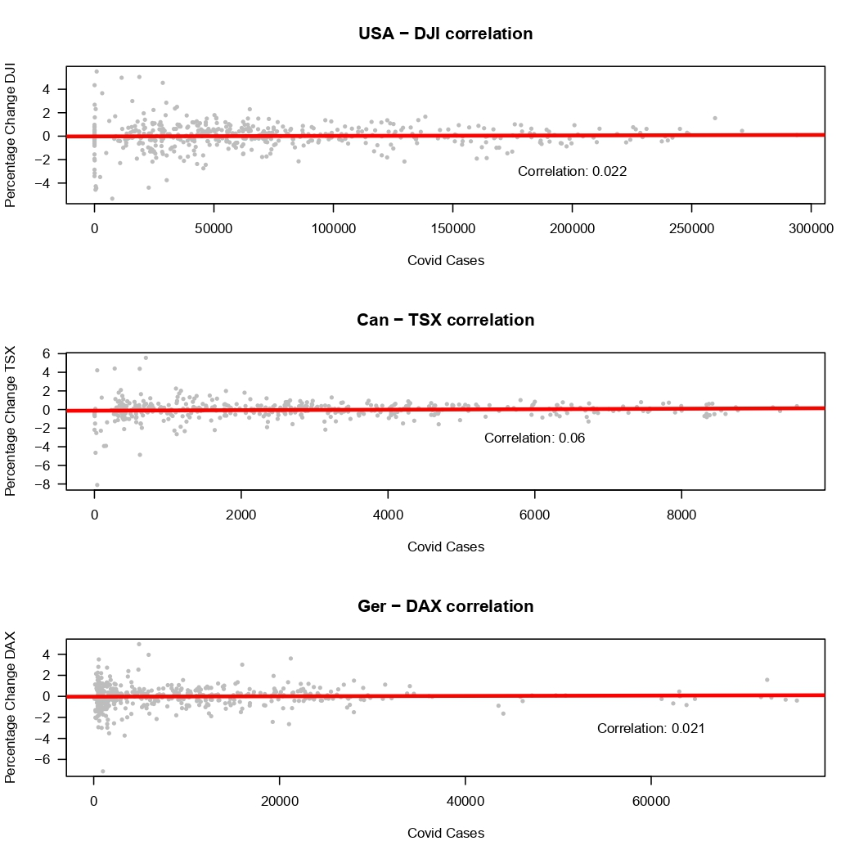

*Figure 3. Correlation between daily COVID-19 cases and the percentage difference between the daily opening and closing stock market prices in three countries*  
(from top to bottom): The United States of America, Canada, and Germany. The correlation between the two variables is the highest in Canada and the lowest in Germany. In all three countries, the correlation is very close to zero.

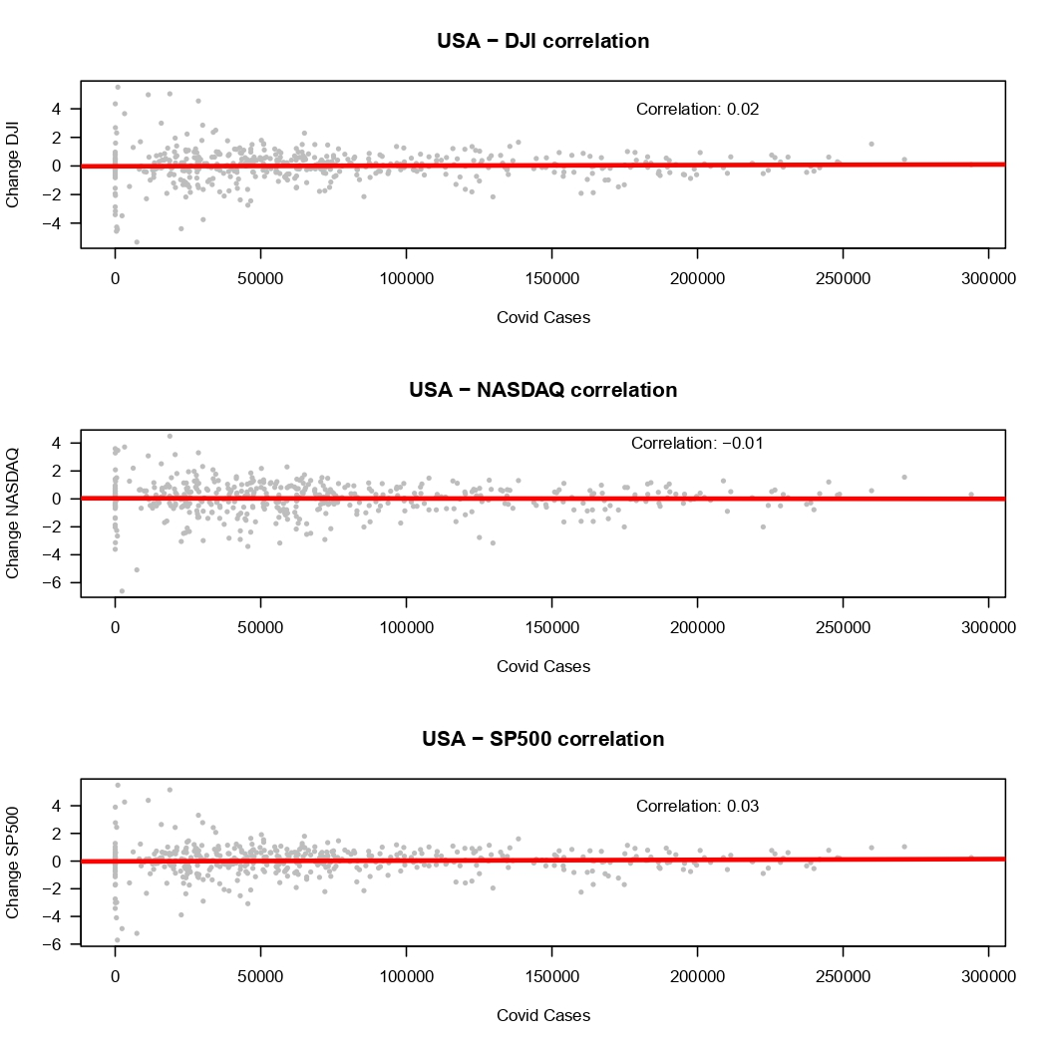

*Figure 4. Correlation between daily COVID-19 cases and the percentage difference between the daily opening and closing stock market prices in the USA*Despite being negative, the USA-NASDAQ correlation coefficient, like the other two demonstrated in this figure, is very close to zero.

**Conclusion**

Based on our results, we cannot reject the null hypothesis. Of the two analyses we performed, the results of one are statistically significant, while the results of the other are statistically insignificant. We do not want to assume that one is a better indicator of market activity than the other, so we propose further investigation to determine whether the number of COVID-19 cases have any correlation with market activity.

There were several limitations to our study. We chose stock indices prices because it provides us with an image of how the economy changes on an almost daily basis. This means that we did not look at other measures that can also give an idea of how a country's economy is doing, including a country's GDP and interest rates. However, this approach might have included more variation in our data. Longer time scale aggregate measures like GDP might provide a better idea of economic activity. Furthermore, we ran correlational tests that work best on continuous data variables. Although we realized this assumption might not hold for the number of daily COVID-19 cases, a numeric but discrete variable, we decided to use it anyway because the other correlation tests were not working with our data. Interpreting the strength of correlation between covid cases and market activity would also involve investigating other extreme events that we did not explore in this analysis. Future research should take these limitations into account when designing their study.

**References**

[Rubin, D., Huang, J., Fisher, B. T., Gasparrini, A., Tam, V., Song, L., Wang, X., Kaufman, J., Fitzpatrick, K., Jain, A., Griffis, H., Crammer, K., Morris, J., & Tasian, G. (2020). Association of Social Distancing, Population Density, and Temperature With the Instantaneous Reproduction Number of SARS-CoV-2 in Counties Across the United States. *JAMA Network Open*, *3*(7), e2016099. https://doi.org/10.1001/jamanetworkopen.2020.16099](https://www.zotero.org/google-docs/?gk3QMS)

[Sen-Crowe, B., McKenney, M., & Elkbuli, A. (2020). Social distancing during the COVID-19 pandemic: Staying home save lives. *The American Journal of Emergency Medicine*, *38*(7), 1519–1520. https://doi.org/10.1016/j.ajem.2020.03.063](https://www.zotero.org/google-docs/?gk3QMS)

**Appendix: Data sources**

**USA COVID-19 Cases**

CDC: <https://data.cdc.gov/Case-Surveillance/United-States-COVID-19-Cases-and-Deaths-by-State-o/9mfq-cb36/data>

**Canada COVID-19 Cases**

Health Canada:  
<https://health-infobase.canada.ca/covid-19/epidemiological-summary-covid-19-cases.html>

**Germany COVID-19 Cases**

Data World:  
<https://data.world/liz-friedman/covid-19-in-germany/file/cases-rki-by-state.csv>

**Tsx Composite Index**

Yahoo Finance:  
[https://finance.yahoo.com/quote/^GSPTSE/history?period1=1546300800&period2=1638662400&interval=1d&filter=history&frequency=1d&includeAdjustedClose=true](https://finance.yahoo.com/quote/%5EGSPTSE/history?period1=1546300800&period2=1638662400&interval=1d&filter=history&frequency=1d&includeAdjustedClose=true)

**S&P 500 Index**Nasdaq:  
<https://www.nasdaq.com/market-activity/index/spx/historical>

**NASDAQ 100 Index**Yahoo Finance:  
<https://finance.yahoo.com/quote/%5ENDX/history?p=%5ENDX>

**DAX**

Investing:

<https://m.ca.investing.com/etfs/recon-capital-dax-germany>

**DIJA**

Investing:

<https://ca.investing.com/indices/us-30>